AngalurJS Code – SRC Folder and server.js



MySQL



[**https://github.com/Kamal-Goyal-2005/CaltechPG**](https://github.com/Kamal-Goyal-2005/CaltechPG)

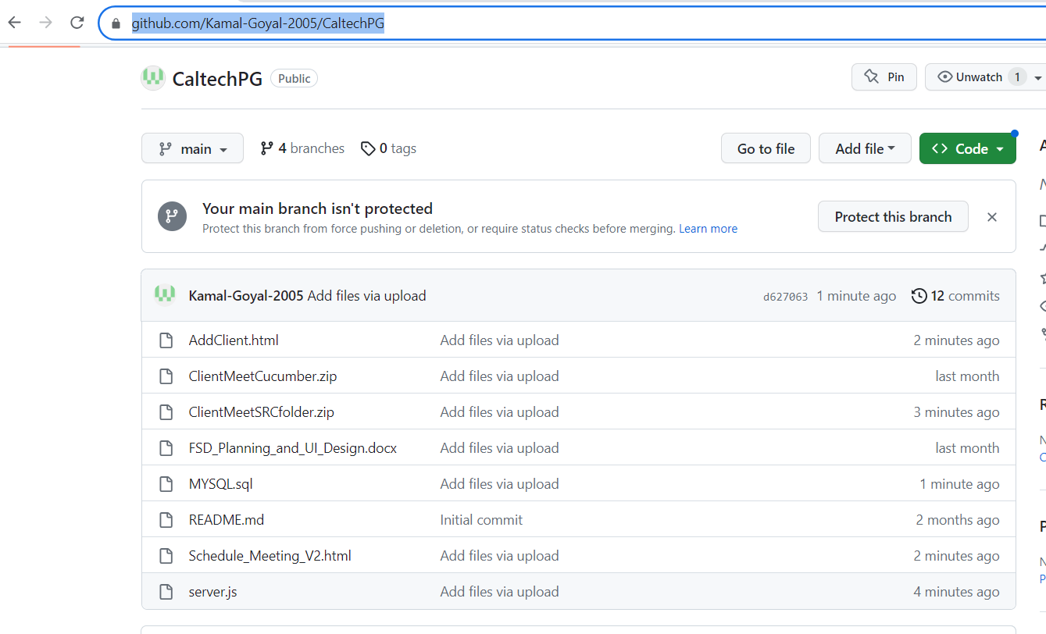

Add Project

|  |  |
| --- | --- |
| Project Name | ClientMeetingMgmt |
| Project Key | CMM |

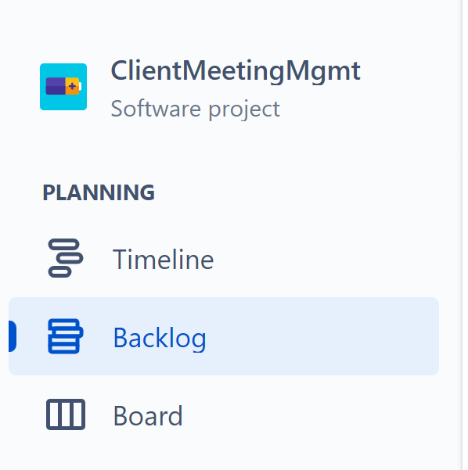

Add Epic

|  |  |
| --- | --- |
| Project | ClientMeetingMgmt (CMM) |
| Issue Type | Epic |
| Summary | Add Client details |
| Description | As Anna, I want to be able to add client details into the software so that this informatica can be used later for various purposes. |

|  |  |
| --- | --- |
| Project | ClientMeetingMgmt (CMM) |
| Issue Type | Epic |
| Summary | Schedule Meeting with Client |
| Description | As Anna, I want to be able to schedule the meetings with Clients so that I can track the meetings. |

Add Story

|  |  |
| --- | --- |
| Project | ClientMeetingMgmt (CMM) |
| Issue Type | Story |
| Summary | Add Client details |
| Description | As Anna, I want to add client details like First Name, Last Name, User Name, Password, Address Line1, Address Line 2, Address Line 3, City, State, Country, Contact Number, Email into the software so that I can store the client information |
| Acceptance Criteria | A web page with a form having text fields to enter Client First Name, Last Name, User Name, Address Line1, Address Line 2, Address Line 3, City, State, Country, Contact Number, Email Address and a button on click of which Client would be added to the DB |
| Validation | Client First Name and Last Namecannot be empty  Client User Name cannot be empty  Client Address Line1 cannot be empty  Client Email cannot be empty  Client Contact Number cannot be empty  Client Password should not be displayed in UI by default. If Show Password checkbox is selected then Password should be shown in UI  Validate Password – Minimum length of 6 with at least 1 lowercase, 1 uppercase and 1 number |
| NFR | Client should be added into the system within 3 seconds |

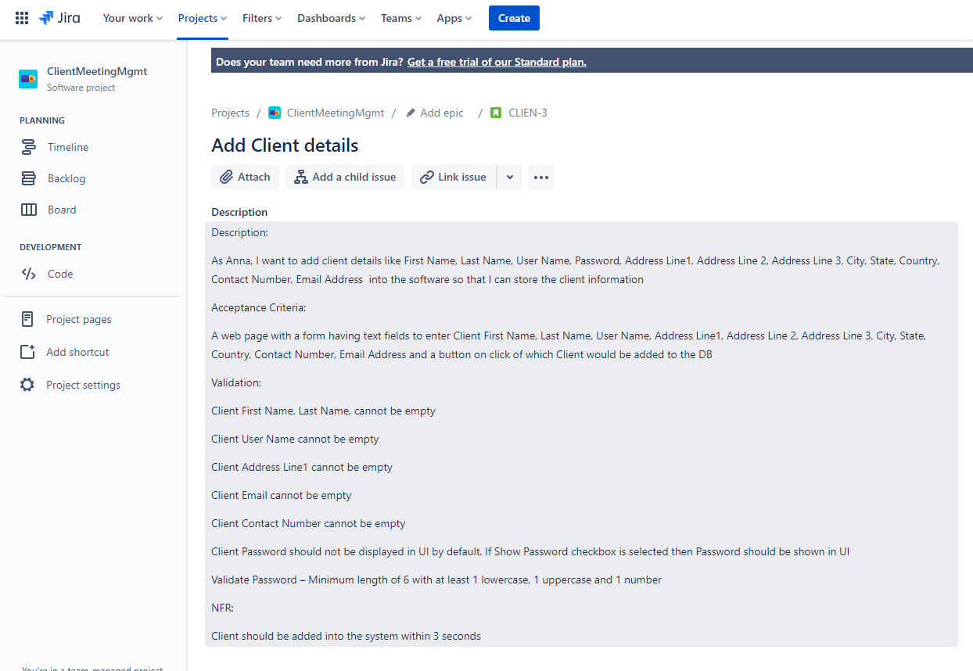

|  |  |
| --- | --- |
| Project | ClientMeetingMgmt (CMM) |
| Issue Type | Story |
| Summary | Schedule meeting with Client |
| Description | As Anna, I want to be able to schedule the meetings with Client with basic details like Meeting Title, Date and Time of the Meeting, No of people, location of meeting, meeting duration and meeting password so that I can plan the meeting with client at the scheduled time |
| Acceptance Criteria | A web page with a form having Calendar to select the date, time and duration for the meeting and text fields to add the agenda of the meeting and place of the meeting. |
| Validation | User should not be allowed to select past date for scheduling the meeting  Date, Time and duration cannot be empty  Purpose or Agenda of the meeting cannot be empty  Default the place of the meeting to zoom if empty |
|  |  |

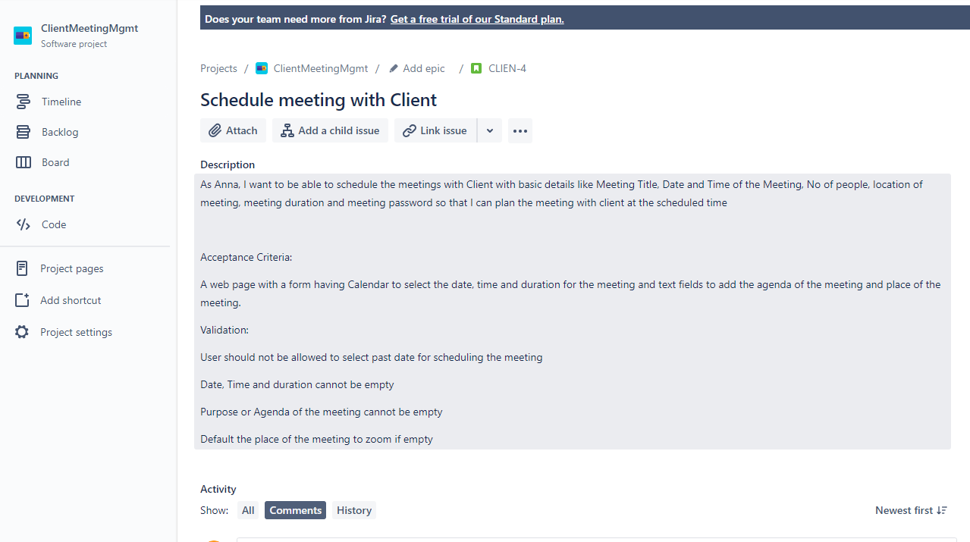

|  |  |
| --- | --- |
| Project | ClientMeetingMgmt (CMM) |
| Issue Type | Story |
| Summary | Cancel scheduled meeting(s) with Client |
| Description | As Anna, I want to be able to cancel the scheduled meetings so that I can have the updated scheduled of the meetings. |
| Acceptance Criteria | A web page with the scheduled meetings and a delete button to delete the scheduled meeting. |

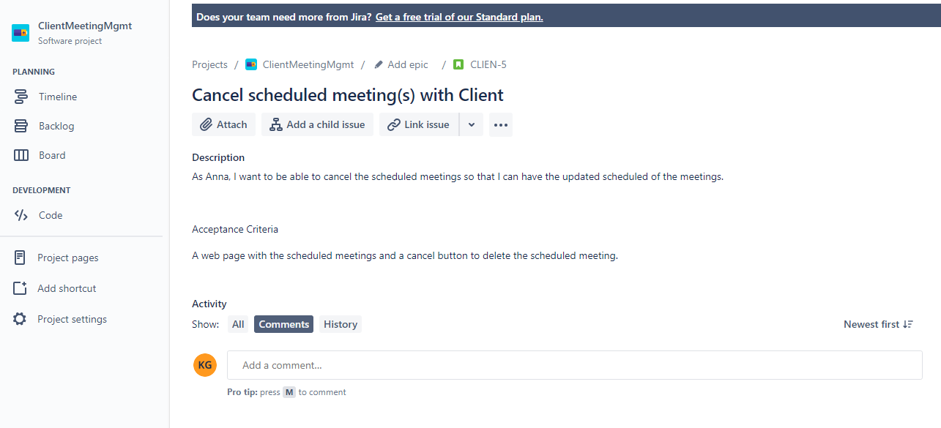

Create Sprint

|  |  |  |
| --- | --- | --- |
| SL No | Story | Sprint |
| 1 | Add Client details | Sprint 1 |
| 2 | Schedule Meeting with Client | Sprint 2 |
| 3 | Cancel scheduled meeting(s) with Client | Sprint 3 |

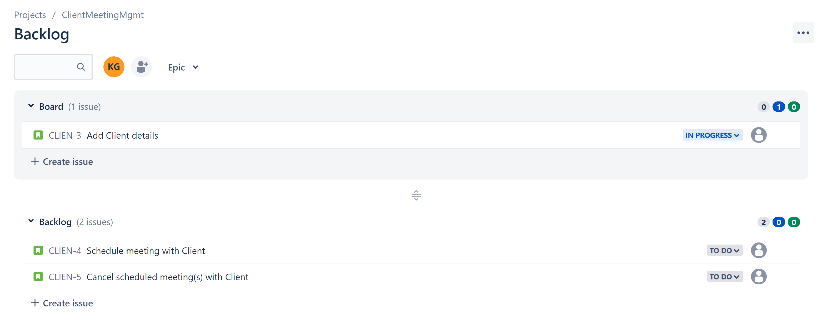

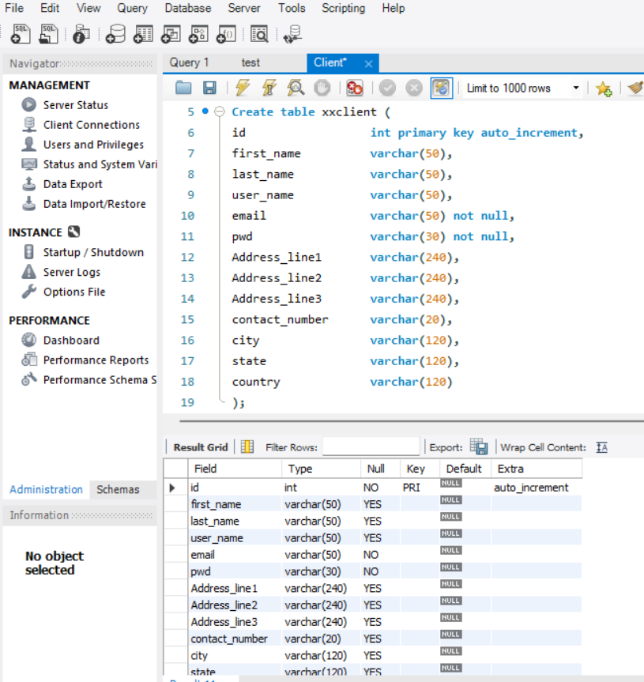

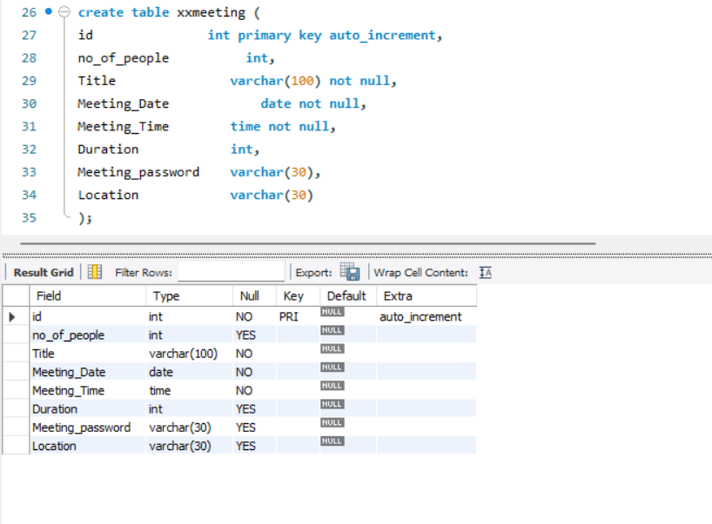

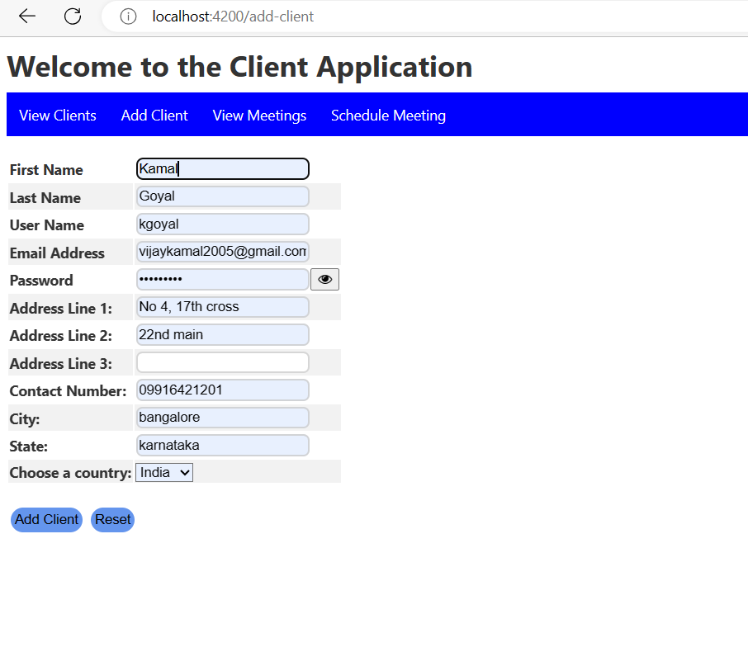

On click of eye:

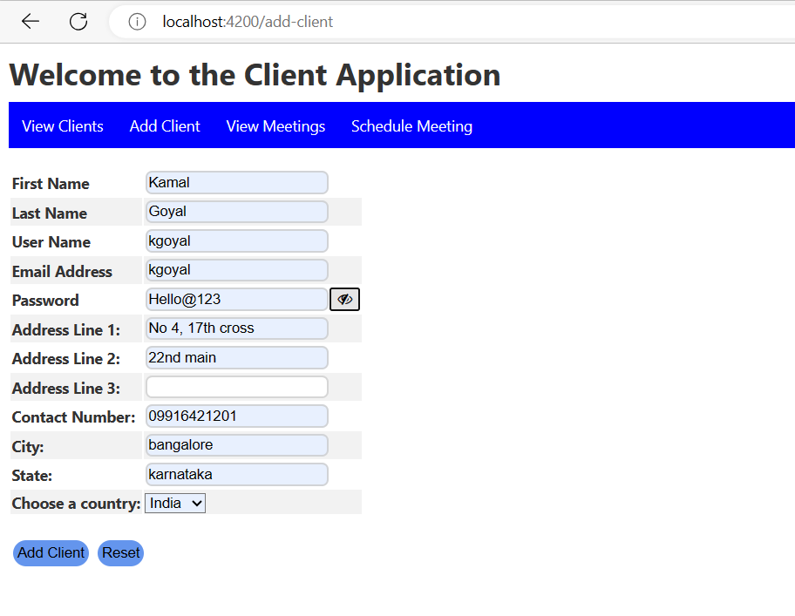

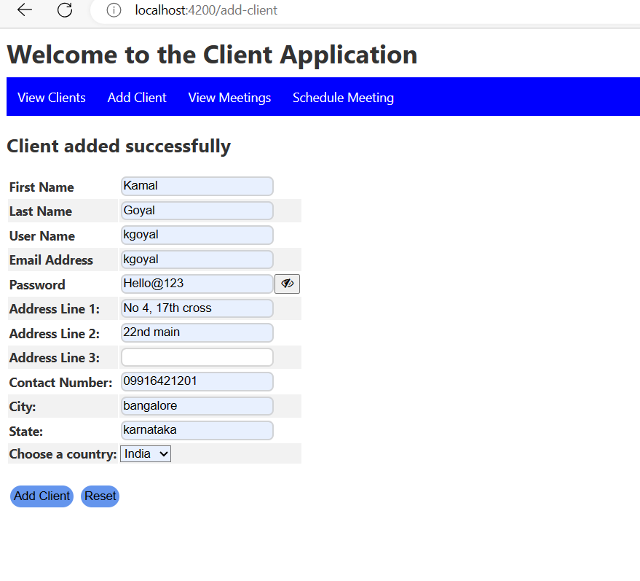

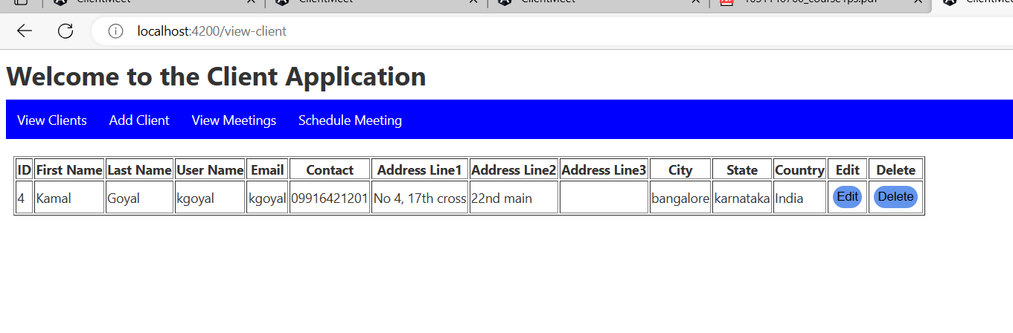

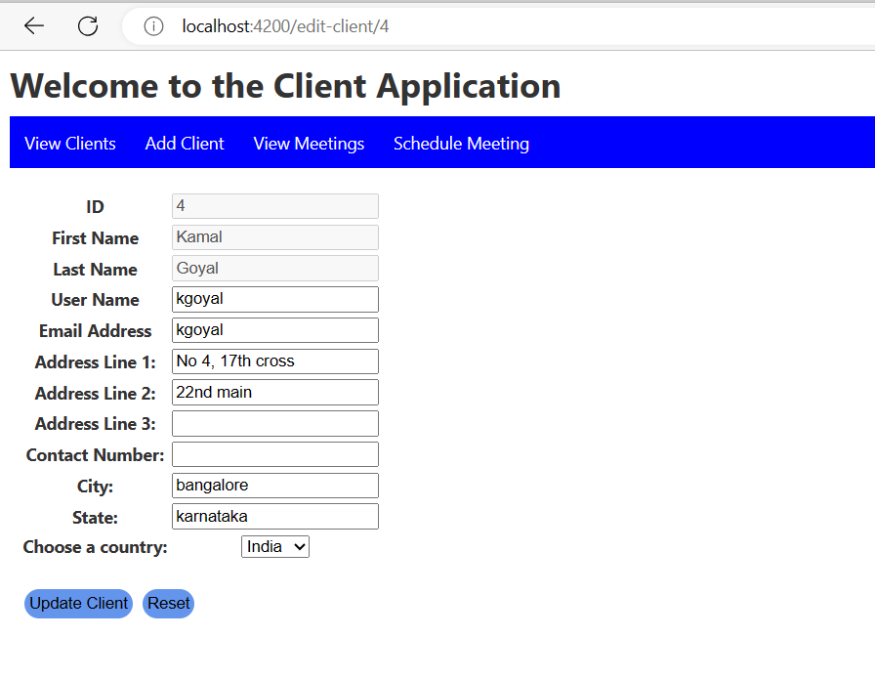

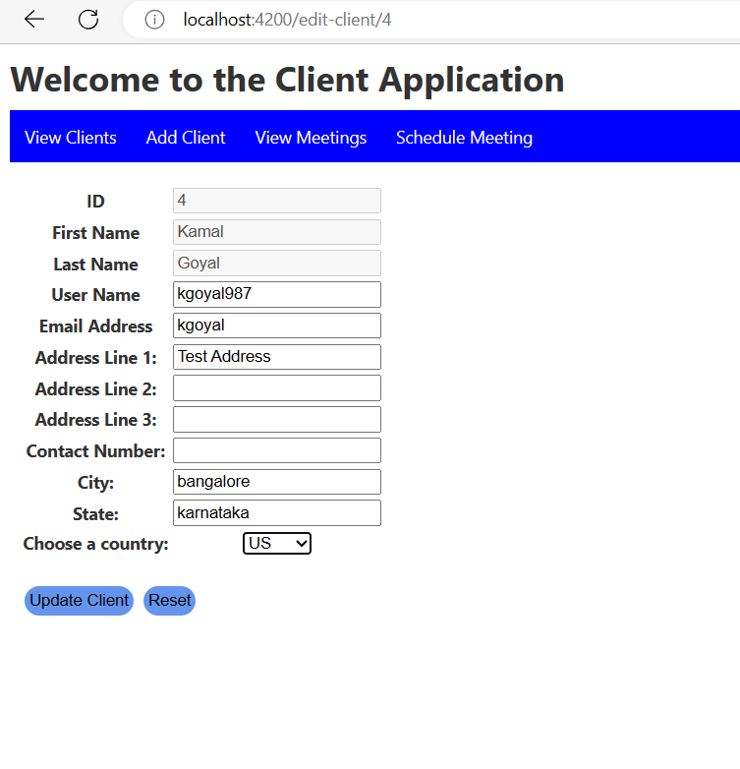

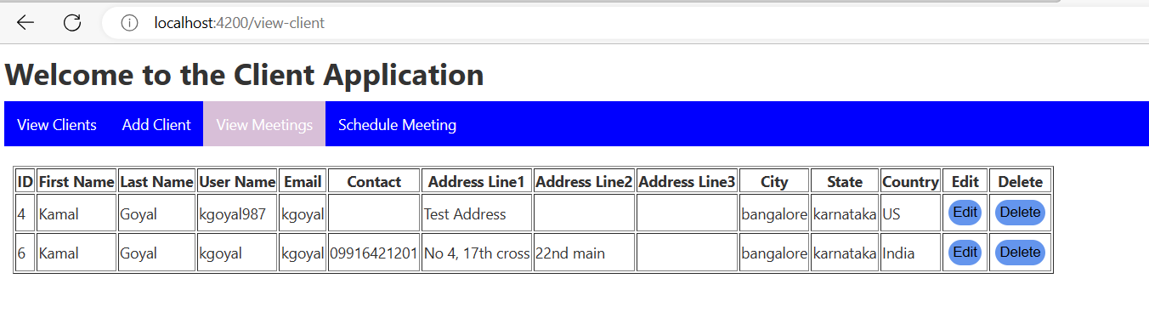

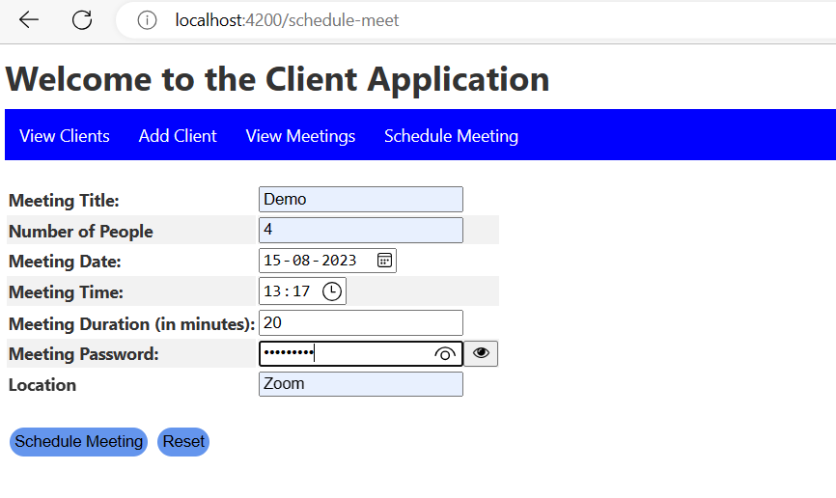

User cannot select any past date for scheduling meeting

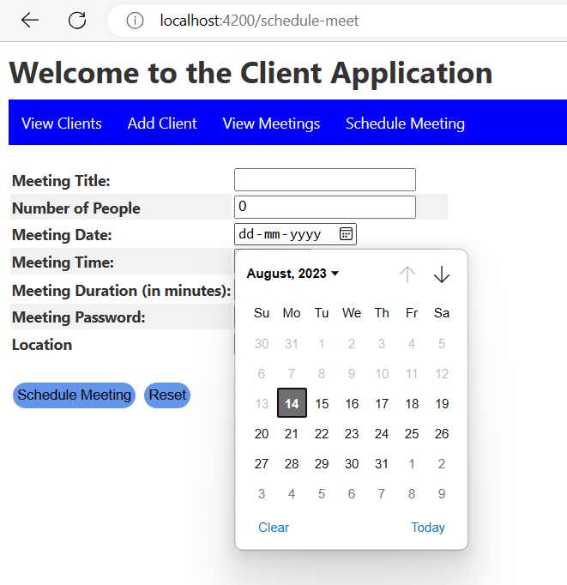

On Show Password Click

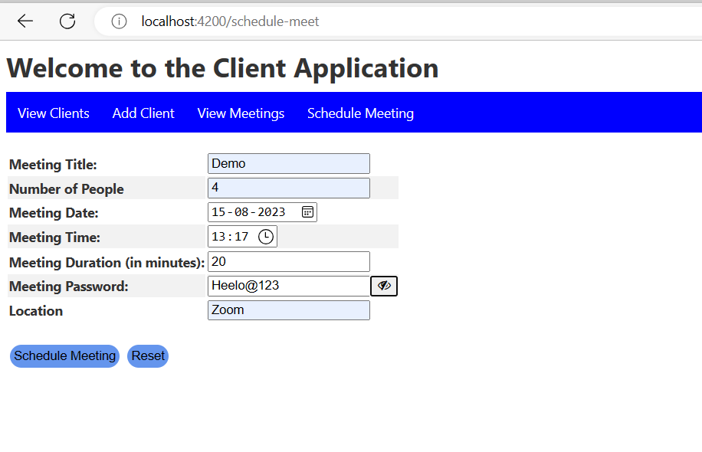

Angular JS

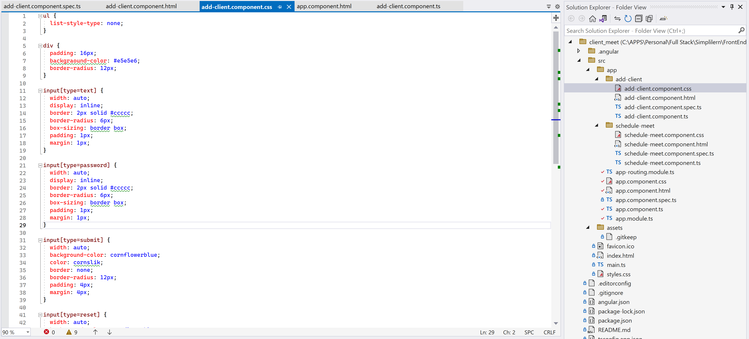

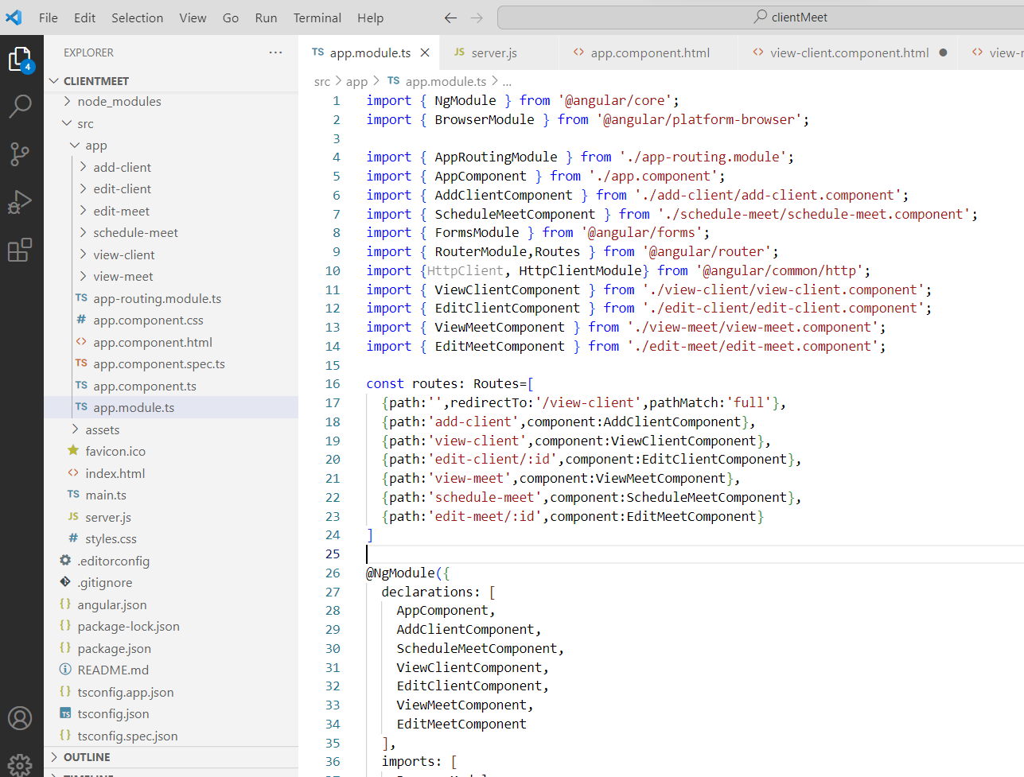

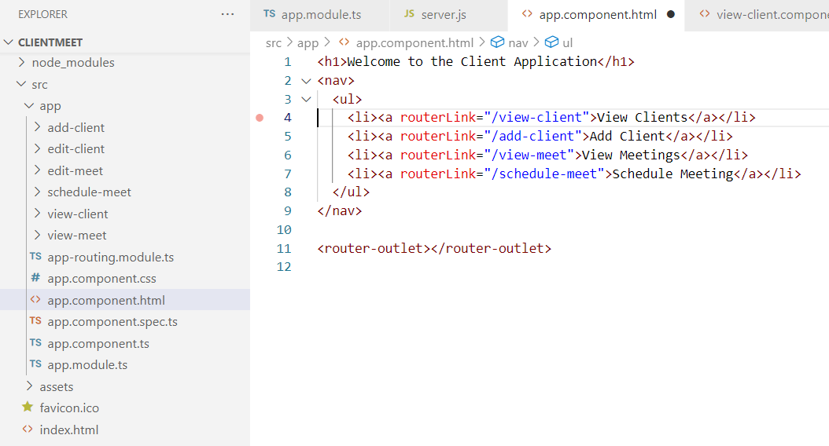

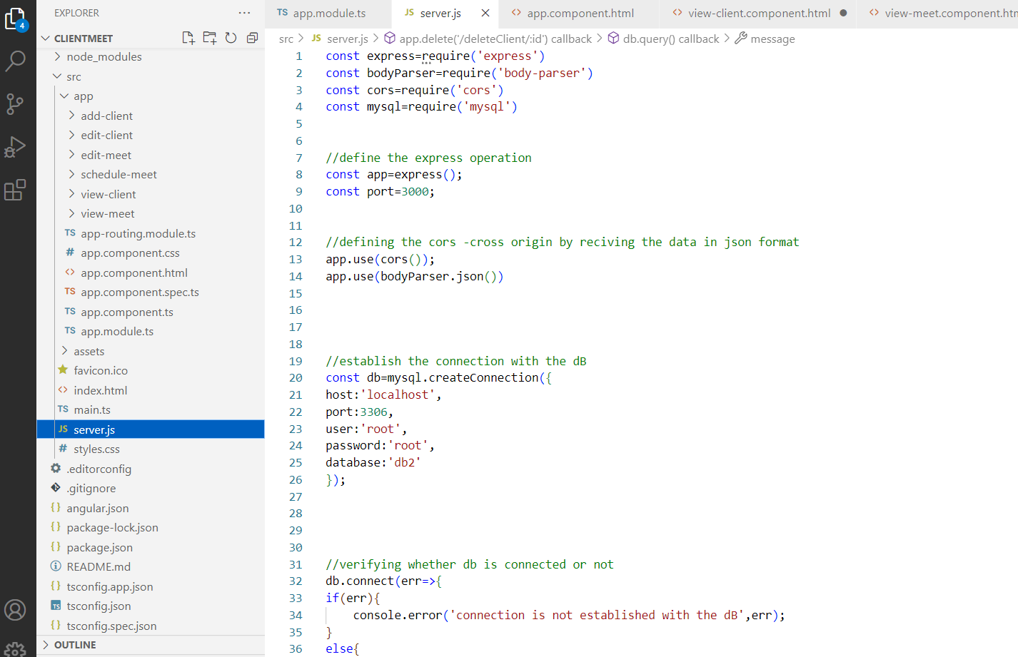

Cucumber



